Experiment 3.3

**Student Name: UID:**

**Branch: CSE Section/Group:607A**

**Semester: 4th Date of Performance: 28/04/2022**

**Subject Name:Programming in Python Lab Subject Code: 22E-20CSP-259**

1. **Aim/Overview of the practical:**

**Q1. Write a Python program to generate 26 text files named A.txt, B.txt, and so on up to Z.txt**

**2) Task to be done/ Which logistics used:**

**To write a python program to generate 26 text files named A.txt, B.txt, and so on up to Z.txt**

**3) Algorithm/Flowchart (For programming based labs):**

**4) Steps for experiment/practical/Code:**

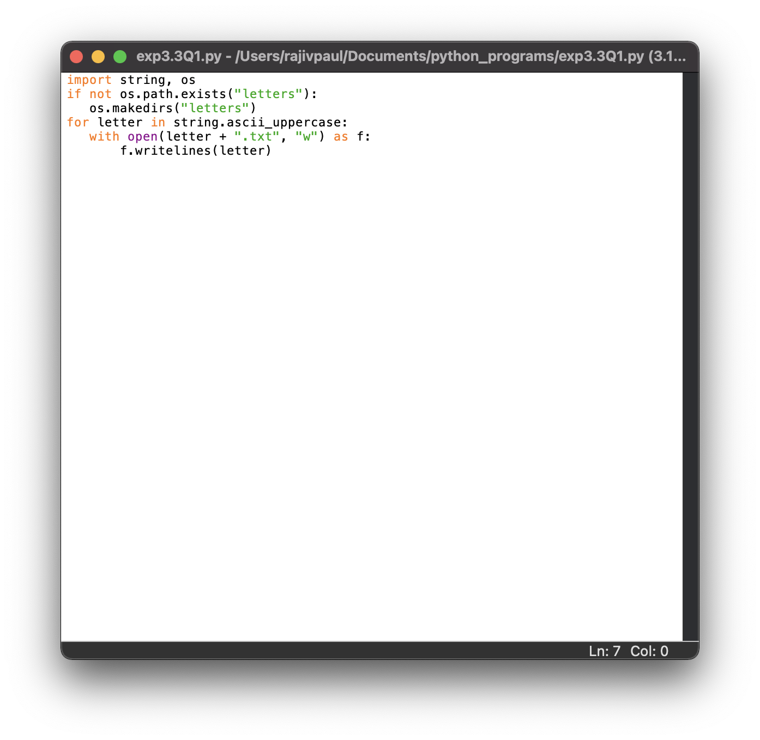

**5. Observations/Discussions/ Complexity Analysis:**

**6. Result/Output/Writing Summary:**

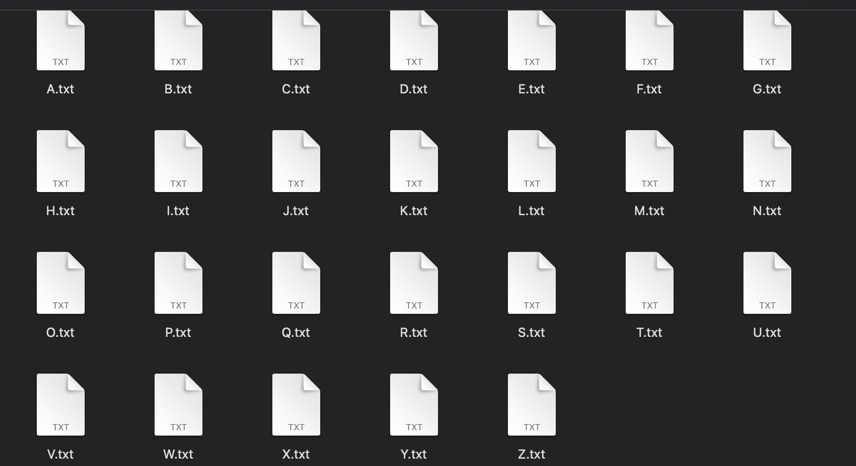

1. **Aim/Overview of the practical:**

**Q2. Write a Python program to create a file where all letters of English alphabet are listed by specified number of letters on each line**

**2) Task to be done/ Which logistics used:**

**To write a python program to create a file where all letters of English alphabet are listed by specified number of letters on each line**

**3) Algorithm/Flowchart (For programming based labs):**

**4) Steps for experiment/practical/Code:**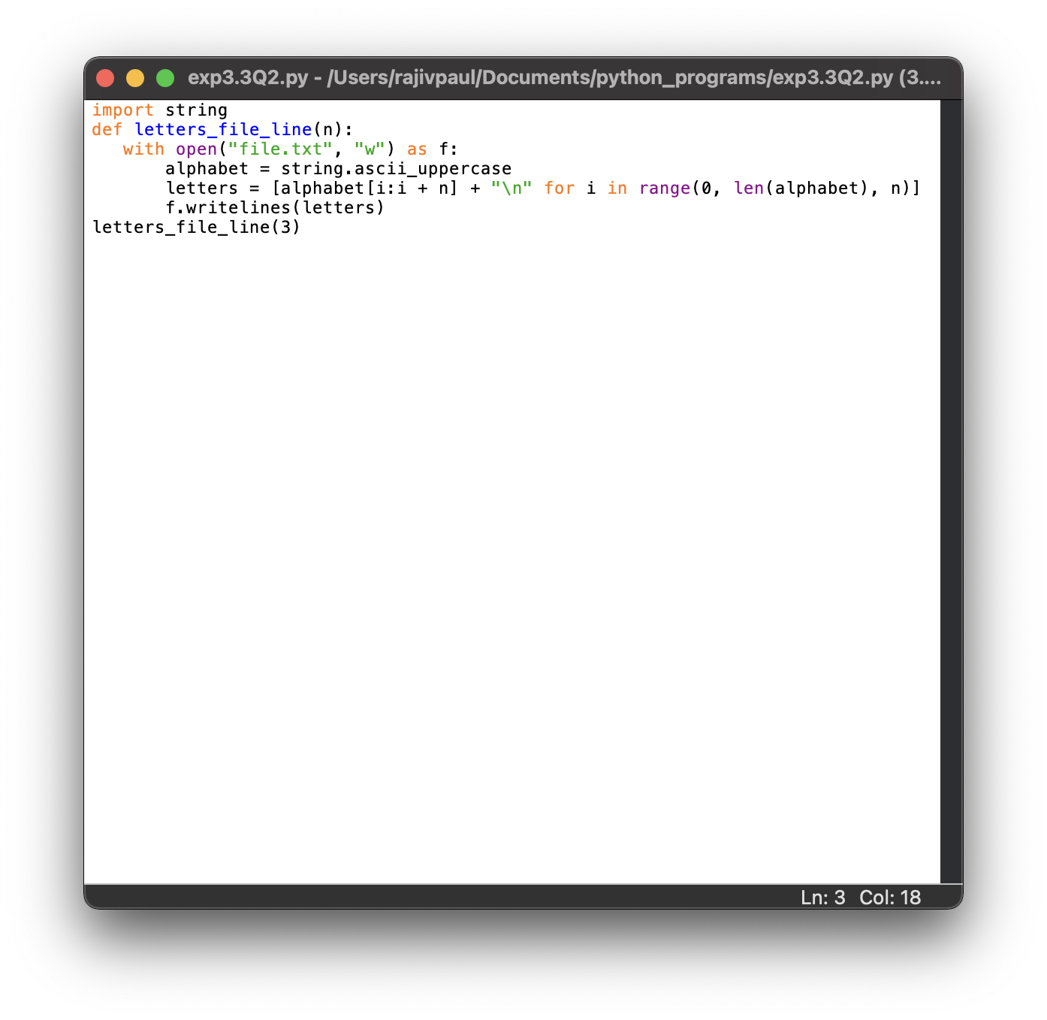

**5. Observations/Discussions/ Complexity Analysis:**

**6. Result/Output/Writing Summary:**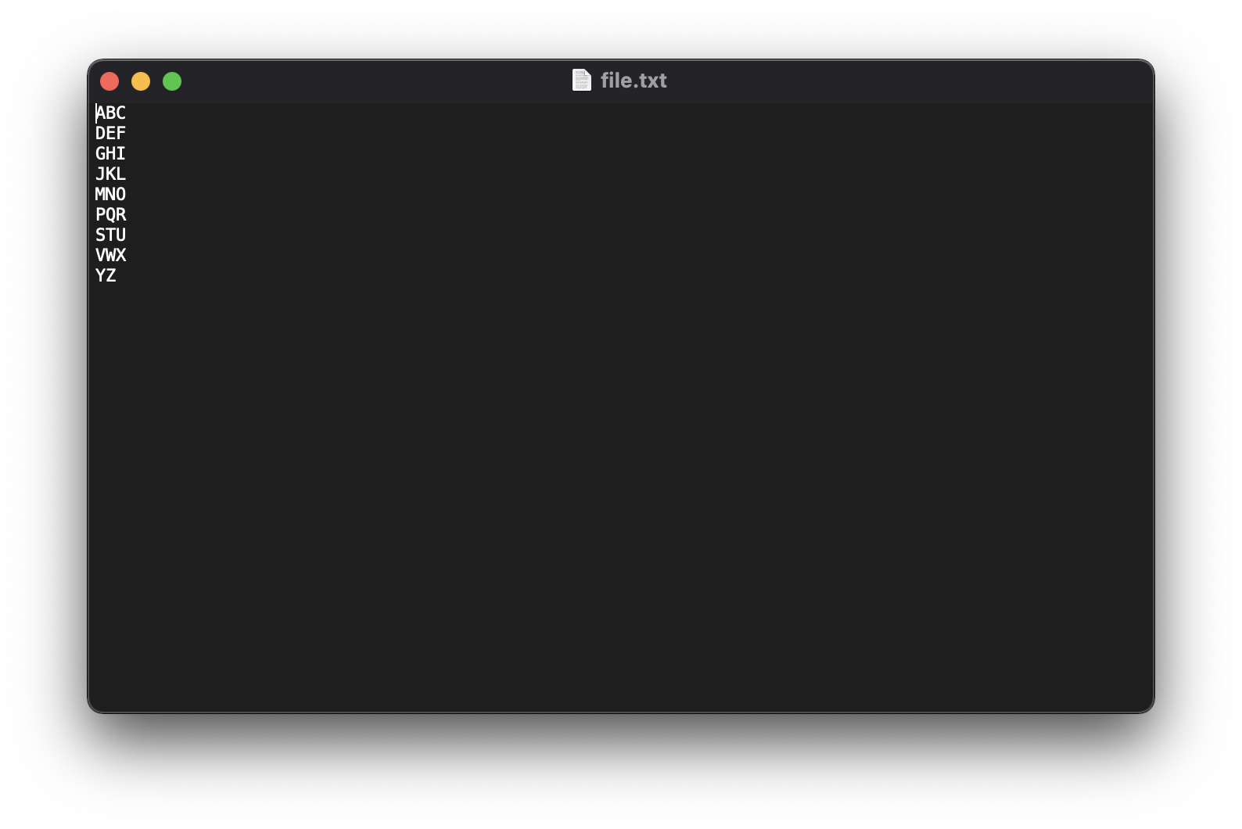

1. **Aim/Overview of the practical:**

**Q3. Write a Python program to read a random line from a file.**

**2) Task to be done/ Which logistics used:**

**To write program to read a random line from a file.**

**3) Algorithm/Flowchart (For programming based labs):**

**4) Steps for experiment/practical/Code:**

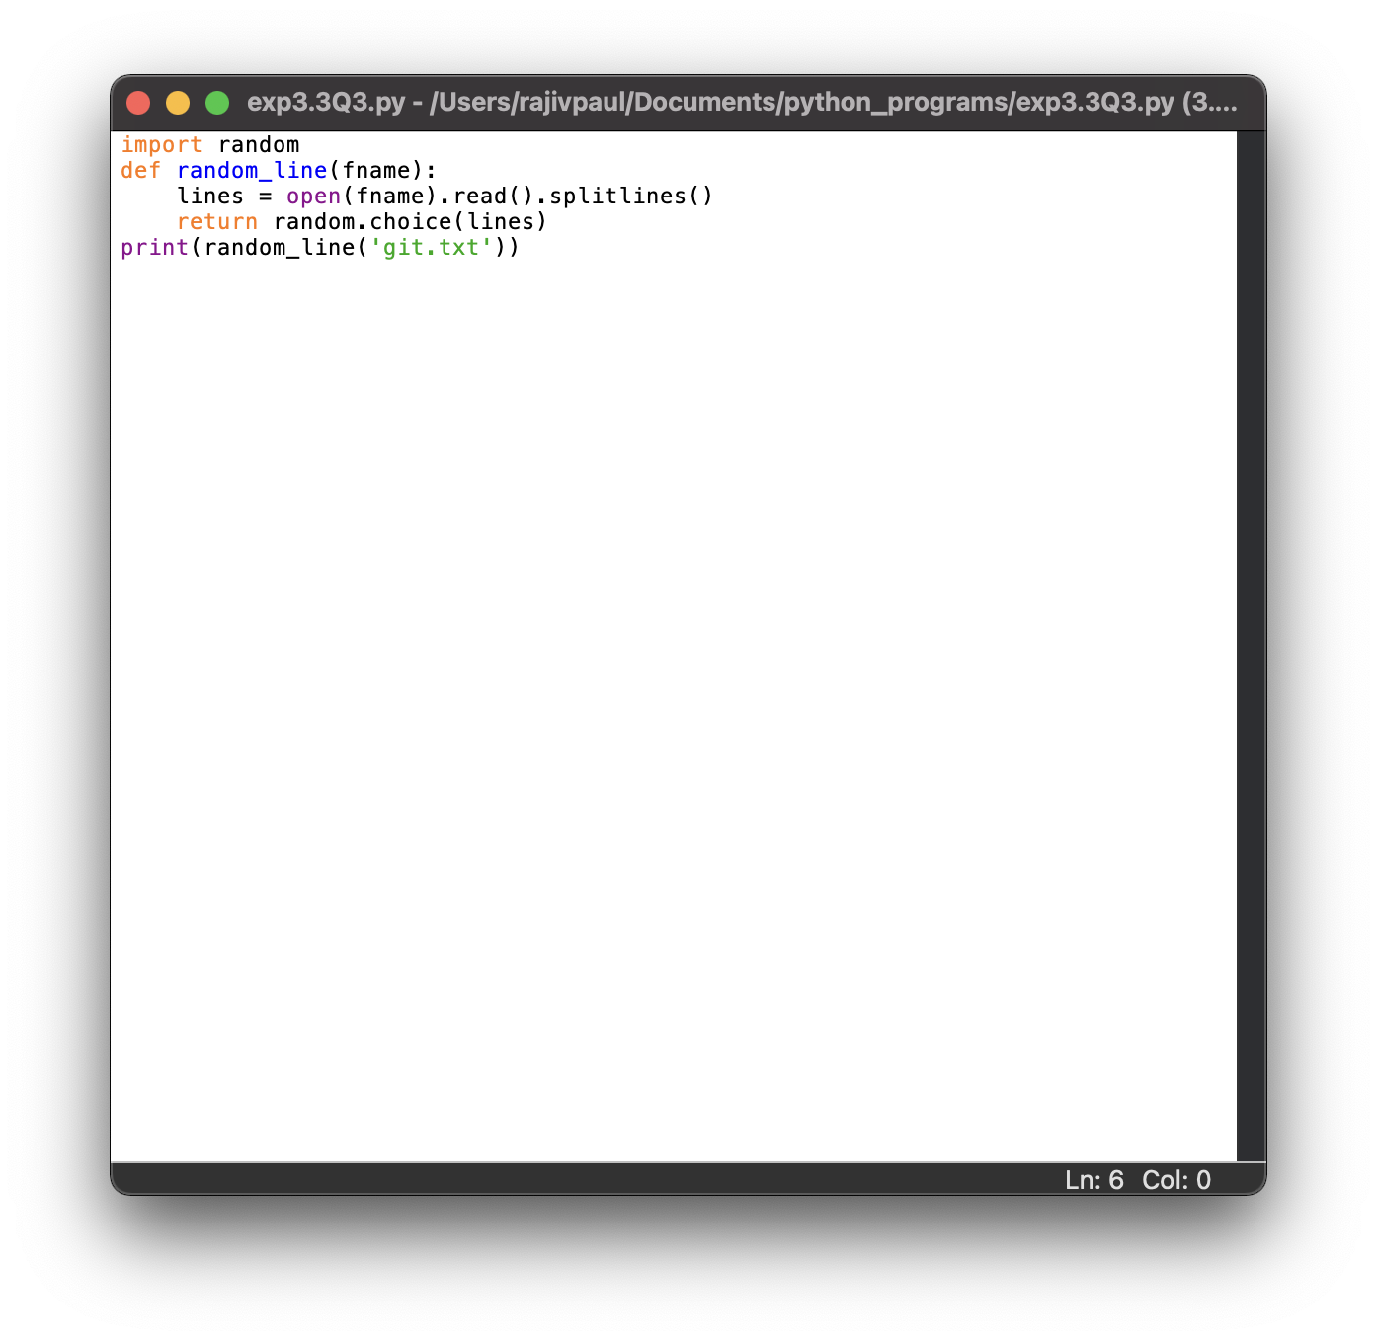

**5. Observations/Discussions/ Complexity Analysis:**

**git.txt file used for the program:**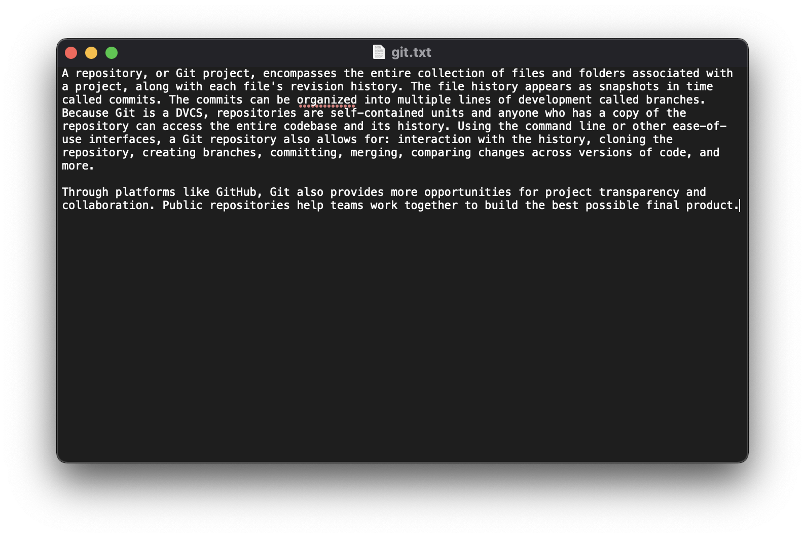

**6. Result/Output/Writing Summary:**

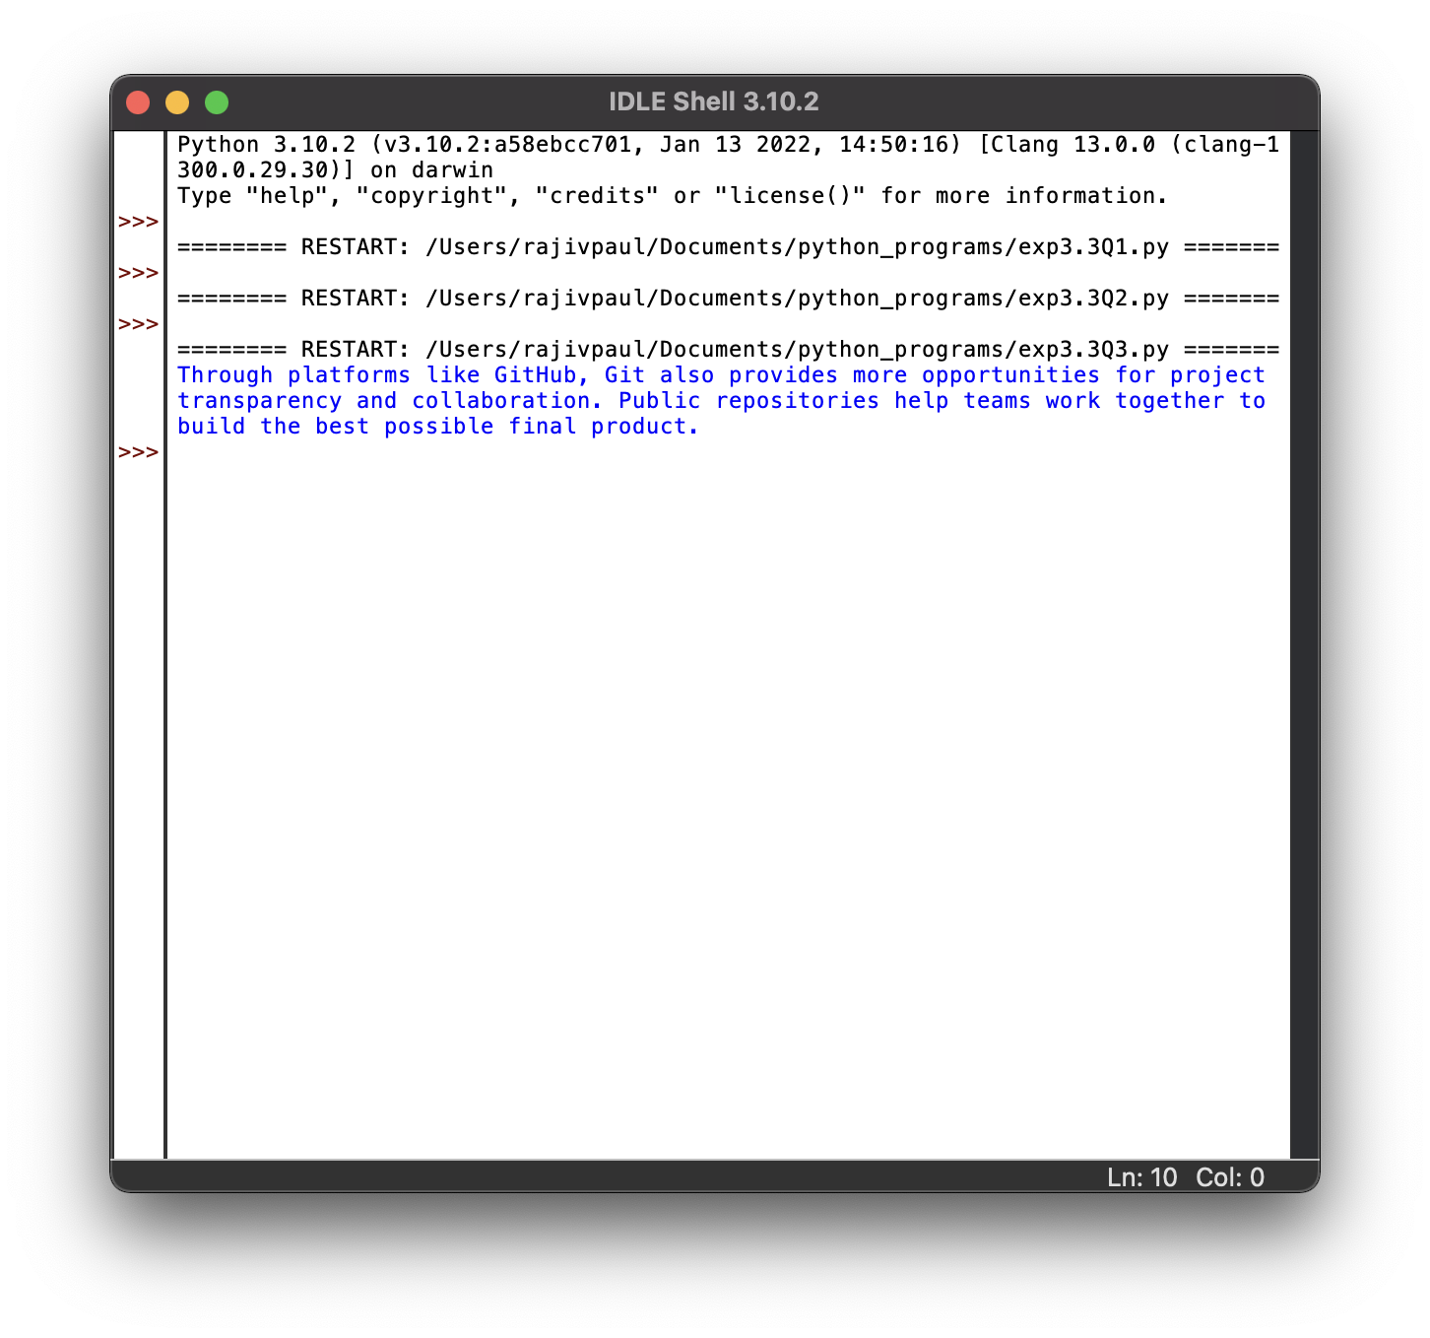

1. **Aim/Overview of the practical:**

**Q4. Write a Python program to count the frequency of words in a file.**

**2) Task to be done/ Which logistics used:**

**To write a python program to count the frequency of words in a file.**

**3) Algorithm/Flowchart (For programming based labs):**

**4) Steps for experiment/practical/Code:**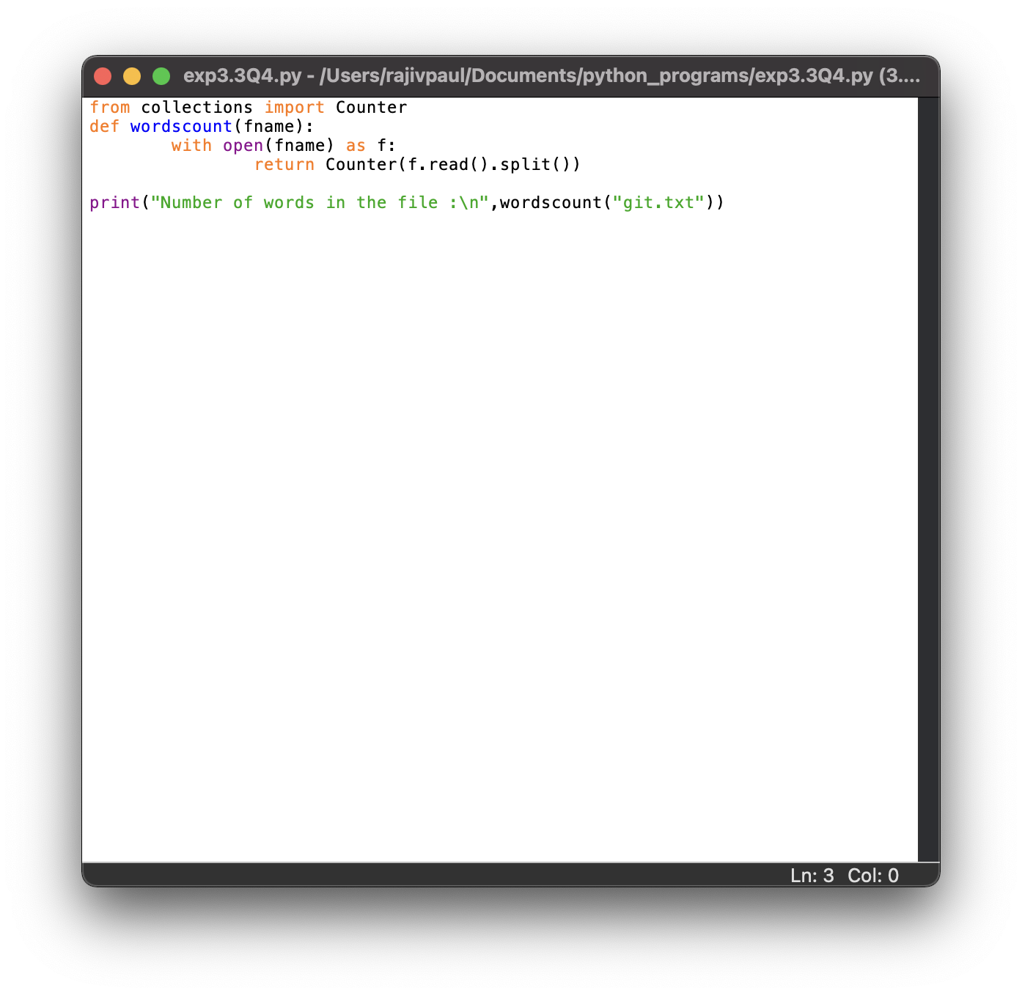

**5. Observations/Discussions/ Complexity Analysis:**

**git.txt file used for the program:**

**6. Result/Output/Writing Summary:**

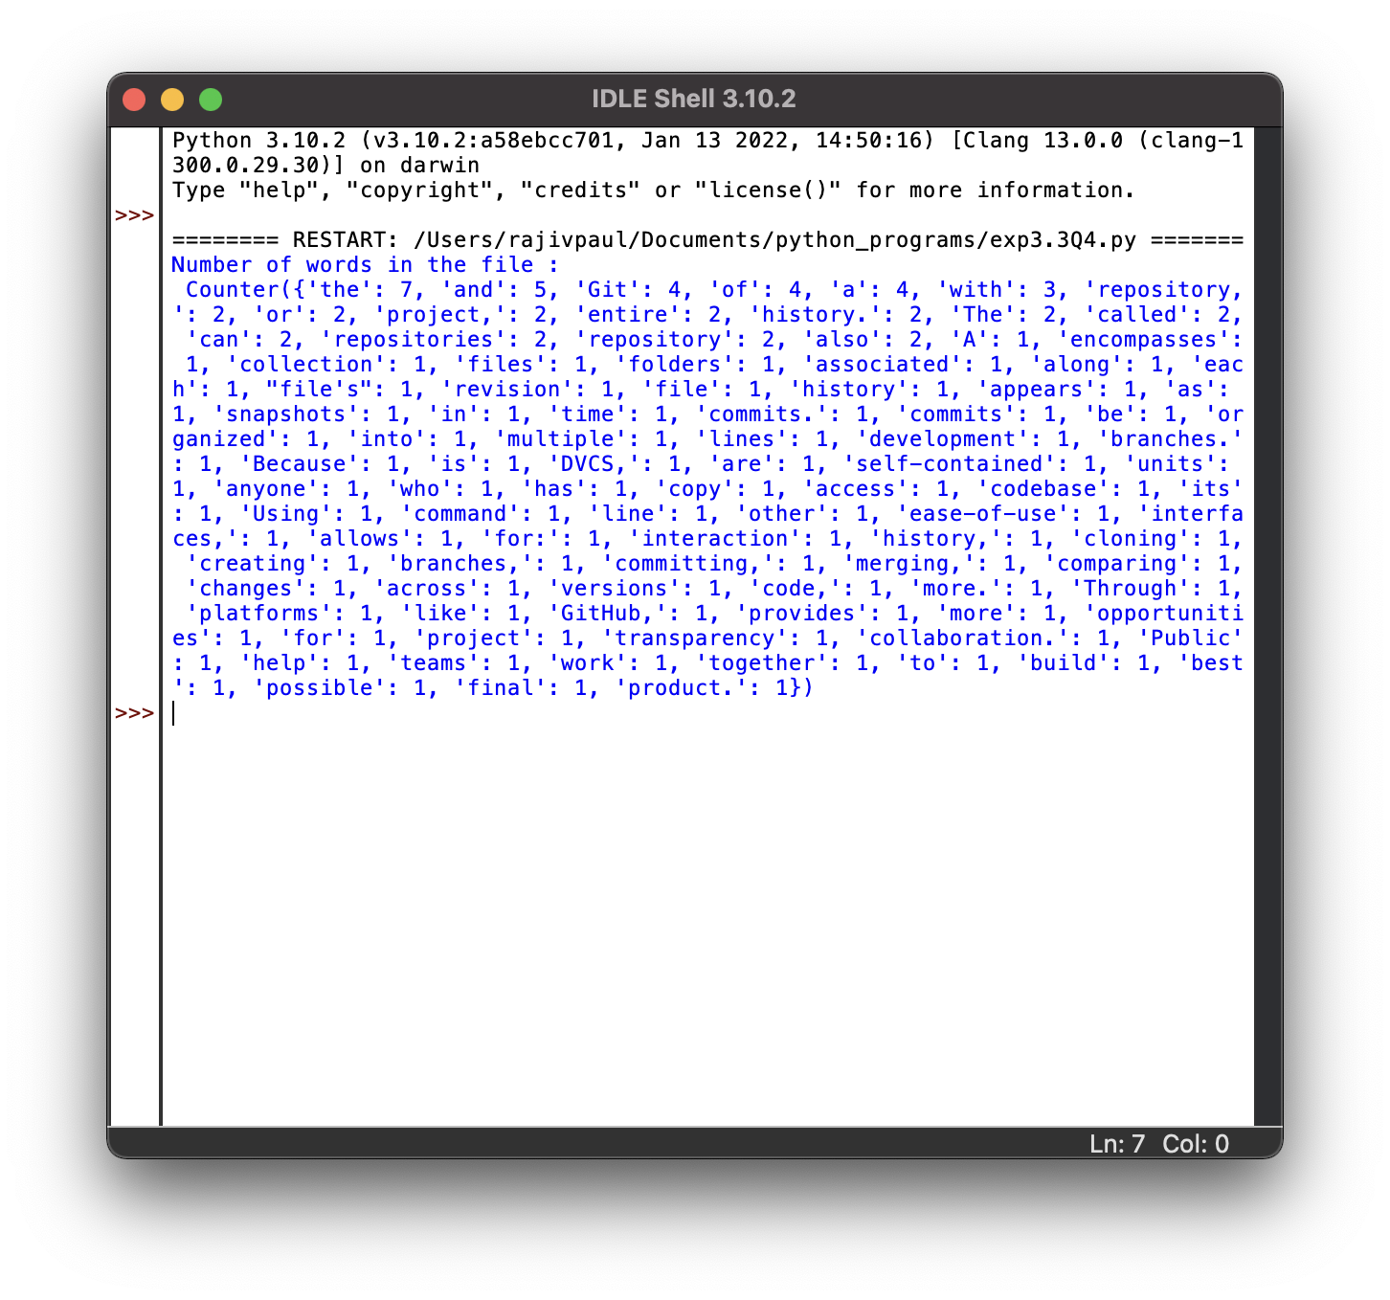

1. **Aim/Overview of the practical:**

**Q5. Write a Python program to copy the contents of a file to another file.**

**2) Task to be done/ Which logistics used:**

**To write a python program to copy the contents of a file to another file.**

**3) Algorithm/Flowchart (For programming based labs):**

**4) Steps for experiment/practical/Code:**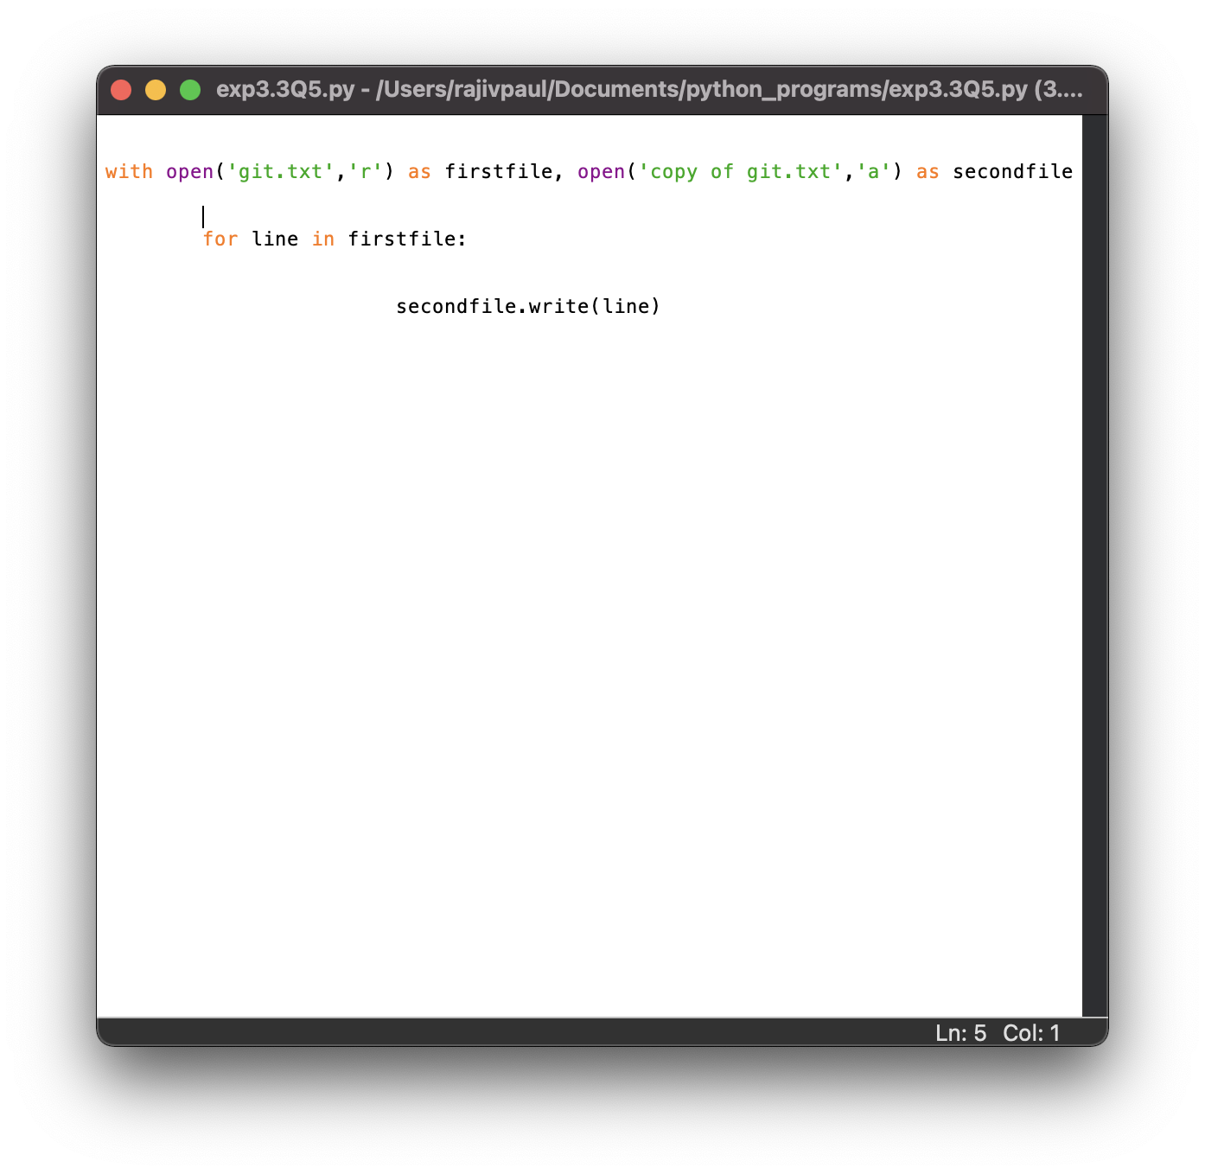

**5. Observations/Discussions/ Complexity Analysis:**

**git.txt file used for the program:**

**copy of git.txt file used for the program:**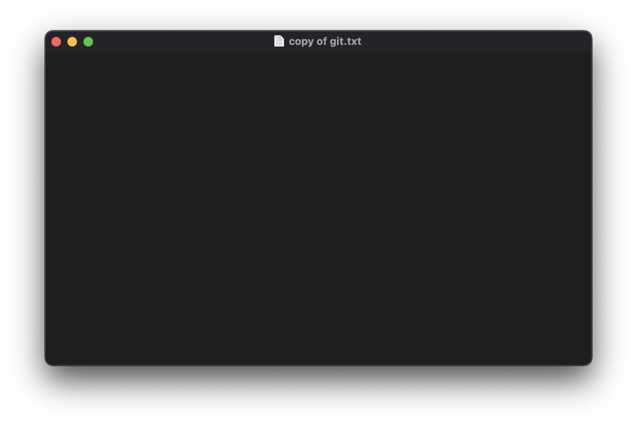

**6. Result/Output/Writing Summary:**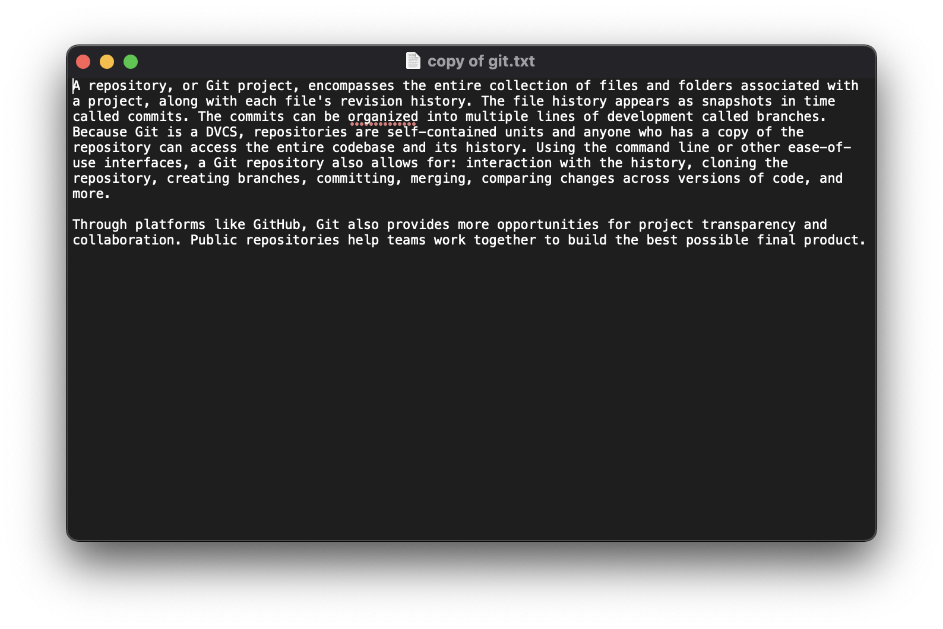

**Evaluation Grid (To be created as per the SOP and Assessment guidelines by the faculty):**

|  |  |  |  |
| --- | --- | --- | --- |
| Sr. No. | Parameters | Marks Obtained | Maximum Marks |
| 1. |  |  |  |
| 2. |  |  |  |
| 3. |  |  |  |
|  |  |  |  |